山西大学计算机与信息技术学院
实验报告
姓 名 | 王江涛 |  | 学 号 | 202301006133 | 专业班级 | 人工智能2301
课程名称 | Java实验 |  |  |  |  | 实验日期 | 2024.5.29
成 绩 |  |  | 指导教师 |  |  | 批改日期
实验名称 |  | 实验8 Java的输入输出流
- 实验目的
1. 理解I/O流的概念，掌握其分类
2. 掌握文本文件读写、二进制文件读写
- 实验内容
1. 分别使用FileWriter 和 BufferedWriter 往文件中写入1万个随机数，比较用时的多少？(用时采用方法System.currentTimeMillis()）求时间差;
使用：FileWriter
程序源代码
import java.io.FileWriter;
import java.io.IOException;
import java.util.Random;
public class Test {
public static void main(String[] args)throws IOException {
long time1=System.currentTimeMillis();
FileWriter f=new FileWriter("c.text");
int num;
Random random=new Random();
for(int i=0;i<=10000;i++){
f.write((int)random.nextDouble());
}
f.close();
long time2=System.currentTimeMillis()-time1;
System.out.println("time:"+time2+"ms");
}
}
程序运行结果贴图
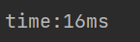
使用：BufferedWriter
程序源代码
package test;
import java.io.BufferedOutputStream;
import java.io.FileNotFoundException;
import java.io.FileOutputStream;
import java.io.IOException;
public class Test {
public static void main(String[] args) throws IOException {
BufferedOutputStream bouput = new BufferedOutputStream(
new FileOutputStream("temp2.dat"));
long start2 = System.currentTimeMillis();
for (int i = 0; i < 10000; i++) {
bouput.write((int) (Math.random()*10));
}
long stop2 = System.currentTimeMillis();
long time2 = stop2-start2;
System.out.println("BufferedWriter:"+ time2 +"ms");
}
}
程序运行结果贴图
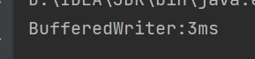
- 课本P547，19.2 ：编写一个文件，如果文件Exercise 19_2.dat 不存在，就创建一个名为Exercise 19_2.txt的文件。向这个文件追加新数据。使用二进制I/O将100个随机生成的整数写入这个文件中。
程序源代码
package test;
import java.io.BufferedOutputStream;
import java.io.DataOutputStream;
import java.io.File;
import java.io.FileNotFoundException;
import java.io.FileOutputStream;
import java.io.IOException;
import java.util.Random;
public class Test {
public static void main(String[] args) throws IOException {
// Check if file Exercise 19_2.dat exists
File file = new File("Exercise 19_2.dat");
if (!file.exists()) {
// If file does not exist, create Exercise 19_2.txt and write to it
file = new File("Exercise 19_2.txt");
BufferedOutputStream bufferedOutput = new BufferedOutputStream(new FileOutputStream(file));
DataOutputStream output = new DataOutputStream(bufferedOutput);
Random random = new Random();
for (int i = 0; i < 100; i++) {
output.writeInt(random.nextInt());
}
output.close();
}
}
}
程序运行结果贴图

- （对二进制数据文件中的所有数据求和）假设已经使用DataOutputStream中的writeInt（int）创建一个名为Exercise 19_3.dat的二进制数据文件，文件包含数目不确定的整数，编写一个程序来计算这些整数的总和。
程序源代码
import java.io.*;
public class Test {
public static void main(String[] args) throws IOException {
FileInputStream fis = new FileInputStream("Exercise 19_2.txt");
DataInputStream dis = new DataInputStream(fis);
int sum = 0;
while (dis.available() > 0) {
int number = dis.readInt();
sum += number;
}
dis.close();
System.out.println("Sum: " + sum);
}
}
程序运行结果贴图
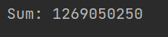
- 在文本文件bigbook.txt中包含有很长篇幅的英语短文，编写程序要求统计文件的所有短文中包含英文字母“A”的个数，并显示统计的时间。
程序源代码
import java.io.DataInputStream;
import java.io.FileInputStream;
import java.io.IOException;
public class Test {
public static void main(String[] args) throws IOException {
DataInputStream input = new DataInputStream(
new FileInputStream("bigbook.txt"));
int s,number=0;
long start = System.currentTimeMillis();
while((s = input.read()) != -1){
if ((char)s == 'A')
number++;
System.out.print((char)s);
}
long stop = System.currentTimeMillis();
long a = stop-start;
System.out.println("\n\nThe number of A is "+number);
System.out.println("It takes "+a+" milliseconds");
}
}
程序运行结果贴图
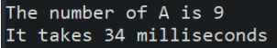
5.编写一个Java应用程序，给当前的类所在的文件ReadExample.java添加行号拷贝到另一个文件temp.text。
程序源代码
package test;
import java.io.BufferedReader;
import java.io.BufferedWriter;
import java.io.FileReader;
import java.io.FileWriter;
import java.io.IOException;
public class Test {
public static void main(String[] args) throws IOException {
BufferedReader input = new BufferedReader(new FileReader("src/text9/ReadExample.java"));
BufferedWriter output = new BufferedWriter(new FileWriter("temp.txt"));
String c;
for (int i = 1;(c = input.readLine()) != null ; i++) {
output.write(i+":"+ c +"\r\n");
}
output.close();
input.close();
}
}
程序运行结果贴图
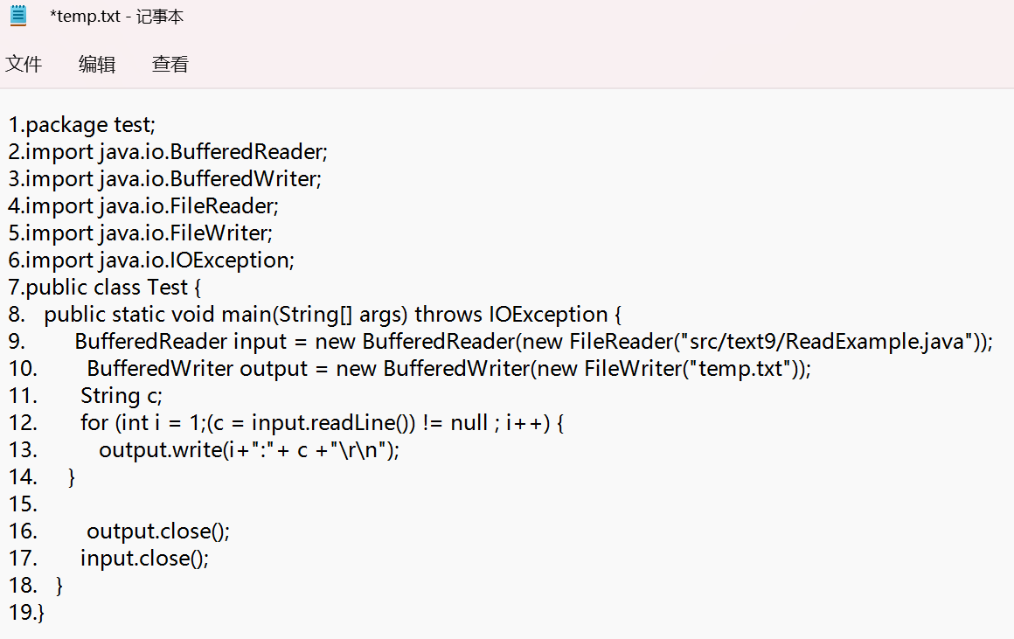
(将对象和数组存储在文件中)编写一个程序，向一个名为Exercise19_5.dat的文件中存储一个含5个int值1,2,3,4,5的数组，存储一个表示当前时间的Date对象，存储一个double值5.5
程序源代码
package test;
import java.io.FileInputStream;
import java.io.FileNotFoundException;
import java.io.FileOutputStream;
import java.io.IOException;
import java.io.ObjectInputStream;
import java.io.ObjectOutput;
import java.io.ObjectOutputStream;
import java.lang.reflect.Array;
import java.util.Arrays;
import java.util.Date;
public class Test {
public static void main(String[] args) throws IOException, IOException, ClassNotFoundException {
int[] array = {1,2,3,4,5};
ObjectOutputStream output = new ObjectOutputStream(new FileOutputStream("Exercise19_5.dat"));
output.writeObject(array);
output.writeObject(new Date());
output.writeDouble(5.5);
output.close();
ObjectInputStream input = new ObjectInputStream(new FileInputStream("Exercise19_5.dat"));
int[] array2 = (int[]) input.readObject();
System.out.println("存储的数组为："+Arrays.toString(array2));
System.out.println("存储的Date对象为："+input.readObject());
System.out.println("存储的double值为："+input.readDouble());
}
}
程序运行结果贴图
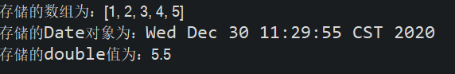
(组合文件)编写一个工具程序，使它能够用下面的命令，将文件组合在一起构成一个新文件：
java Exercise19_12 SourceFile1…SourceFilen TargetFile
这个命令将 SourceFile1,…,SourceFilen合并为TargetFile。
程序源代码
package test;
import java.io.*;
public class Test{
public static void main(String[] args) throws Exception {
if (args.length < 2) {
System.out.println("Usage: java Exercise19_12 SourceFile1…SourceFilen TargetFile");
System.exit(1);
}
try (BufferedOutputStream output = new BufferedOutputStream(new FileOutputStream(args[args.length - 1]))) {
for (int i = 0; i < args.length - 1; i++) {
try (BufferedInputStream input = new BufferedInputStream(new FileInputStream(args[i]))) {
byte[] buffer = new byte[4096];
int bytesRead;
while ((bytesRead = input.read(buffer)) != -1) {
output.write(buffer, 0, bytesRead);
}
}
}
}
}
}
程序运行结果贴图
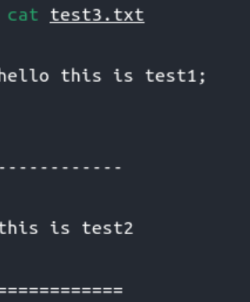
设计一个复数类Complex，并在该类中实现将对象自身保存到文件的功能，实例方法void save（String fileName）；从文件恢复数据的静态方法static Complex load（String fileName）
程序代码：
package test;
import java.util.Scanner;
class Complex {
private double realPart;
private double imaginPart;
Complex(double r, double i) {
this.realPart = r;
this.imaginPart = i;
}
Complex(double real){
this.realPart=real;
this.imaginPart=0;
}
Complex() {
this.realPart = 0;
this.imaginPart = 0;
}
public double getB() {
return this.imaginPart;
}
public double getA() {
return this.realPart;
}
public Complex complexAdd(Complex a) {
Complex c = new Complex();
c.realPart = this.realPart + a.realPart;
c.imaginPart = this.imaginPart + a.imaginPart;
return c;
}
public Complex complexSubtract(Complex a) {
Complex c = new Complex();
c.realPart = this.realPart - a.realPart;
c.imaginPart = this.imaginPart - a.imaginPart;
return c;
}//减法//
public Complex mutiply(Complex a) {
Complex c = new Complex();
c.realPart = this.realPart * a.realPart - this.imaginPart * a.imaginPart;
c.imaginPart = this.realPart * a.imaginPart + this.imaginPart * a.realPart;
return c;
}
public Complex divide(Complex a) {
Complex c = new Complex();
c.realPart = (a.realPart * this.realPart + a.imaginPart * this.imaginPart) / (a.realPart * a.realPart + a.imaginPart * a.imaginPart);
c.imaginPart = (a.realPart * this.imaginPart - this.realPart * a.imaginPart) / (a.realPart * a.realPart + a.imaginPart * a.imaginPart);
return c;
}
public double calAbs() {
double temp = Math.sqrt(this.realPart * this.realPart +this.imaginPart * this.imaginPart);
return temp;
}//求模//
public String toString() {
if (this.realPart >= 0 && this.realPart < 0.01) {
if (this.imaginPart >= 0 && this.imaginPart < 0.01)
return "0.00";
else
return String.format("%.2fi", this.imaginPart);
}
else {
if (this.imaginPart >= 0 && this.imaginPart < 0.01)
return String.format("%.2f", this.realPart);
else
if (this.imaginPart > 0)
return String.format("%.2f+%.2fi", this.realPart, this.imaginPart);
else
return String.format("%.2f%.2fi", this.realPart, this.imaginPart);
}
}
}
class Main{
public static void main(String[] args) {
Scanner in = new Scanner(System.in);
double real1=in.nextDouble();
double image1=in.nextDouble();
double real2=in.nextDouble();
double image2=in.nextDouble();
Complex a=new Complex(real1,image1);
Complex b=new Complex(real2,image2);
System.out.printf("Real:%.2f imaginary:%.2f Fabs:%.2fn",a.getA(),a.getB(),a.calAbs());
System.out.printf("Real:%.2f imaginary:%.2f Fabs:%.2fn",b.getA(),b.getB(),b.calAbs());
System.out.println(a.complexAdd(b));
System.out.println(a.complexSubtract(b));
System.out.println(a.mutiply(b));
System.out.println(a.divide(b));
}
}
运行结果贴图:
